**Fixing issue with startup of .net application**

* <https://github.com/asquarezone/DockerZone/commit/14555855fddd6adb5da3d07c1833e09b5639f438?diff=split> for the Dockerfile  
  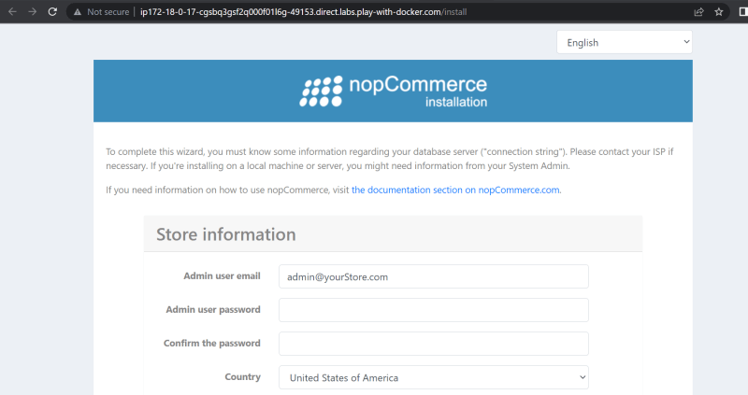
* <https://andrewlock.net/5-ways-to-set-the-urls-for-an-aspnetcore-app/> the document to host the .net application on 0.0.0.0

**Setting Environment Variables in the container**

* ENV instruction <https://docs.docker.com/engine/reference/builder/#env>
* This instruction adds environmental variable in the container and it also allows us to change environmental variables while creating containers
* <https://github.com/asquarezone/DockerZone/commit/07243fd3a974b947c407f12570a9979cbc592025> for the changes done to include environmental variable.
* docker container exec will allow us to execute commands in the container  
  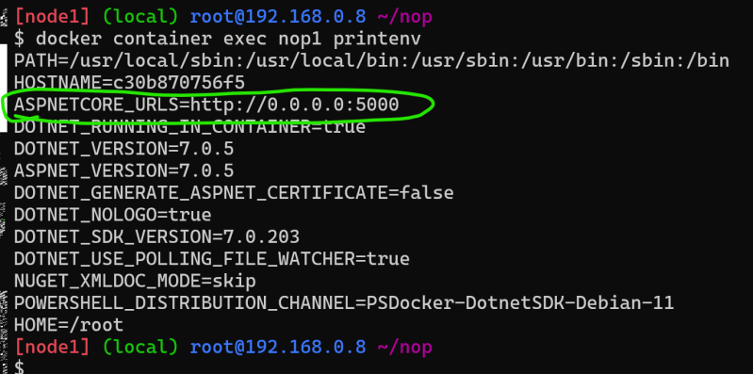
* docker container exec -it <c-name> <shell> will allow us to login into container  
  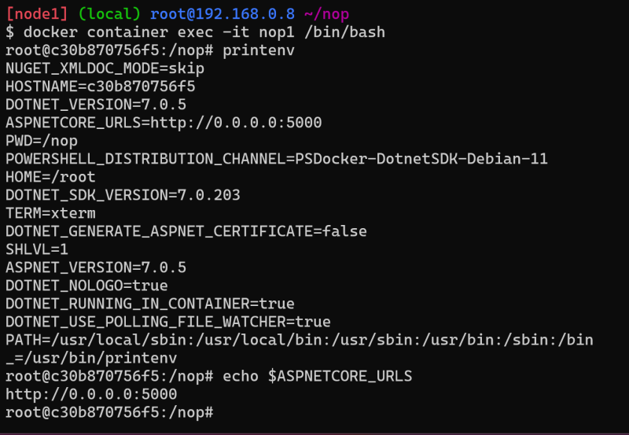

ARG instruction allows us to set the values while building the image <https://docs.docker.com/engine/reference/builder/#arg>

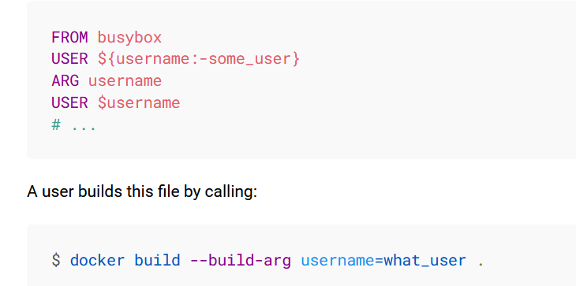

* <https://github.com/asquarezone/DockerZone/commit/60a624985b34fe5b9a82c3fa87204738fd139cd8> for the BUILD ARGS added
* Build args can be set while creating images. BUILD ARG can be used by using ${ARG_NAME}.
* We have build two images by changing the HOME_DIR and DOWNLOAD_URL Build args

docker image build --build-arg DOWNLOAD_URL=nopCommerce_4.60.2_NoSource_linux_x64.zip -t nop:1.0.2 .

docker image build --build-arg HOME_DIR=/publish -t nop:1.0.0 .

USER: https://docs.docker.com/engine/reference/builder/#user

* <https://github.com/asquarezone/DockerZone/commit/9e69fbecc61c60df83697c69d03867e4679a976d> for the changes done to add a non root user to run the nop commerce application.  
  